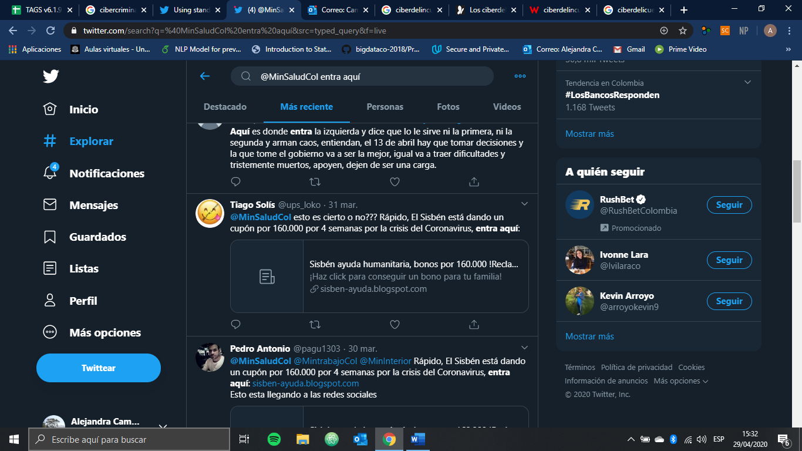

Personas que denuncian. Caos, publicidad engañosas, violencia, subsidio.

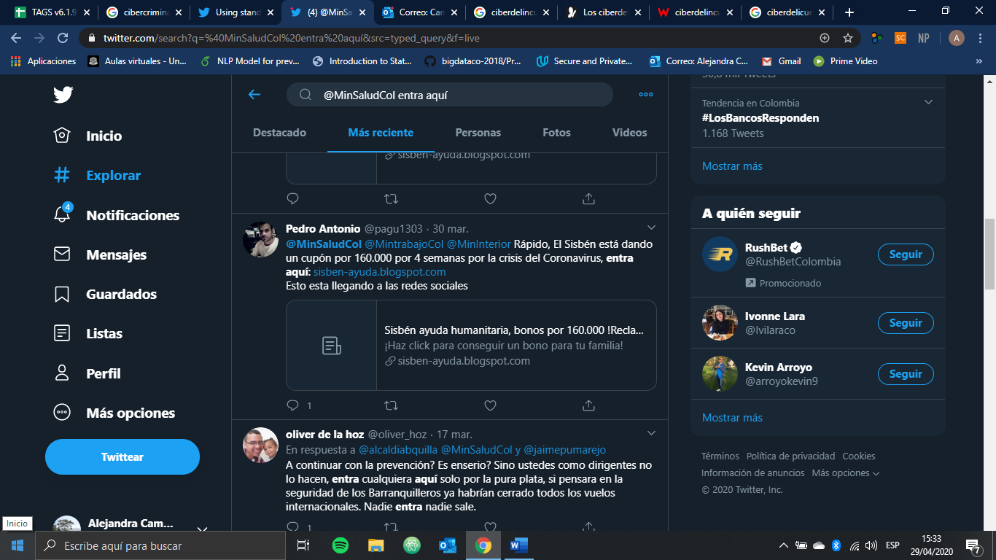

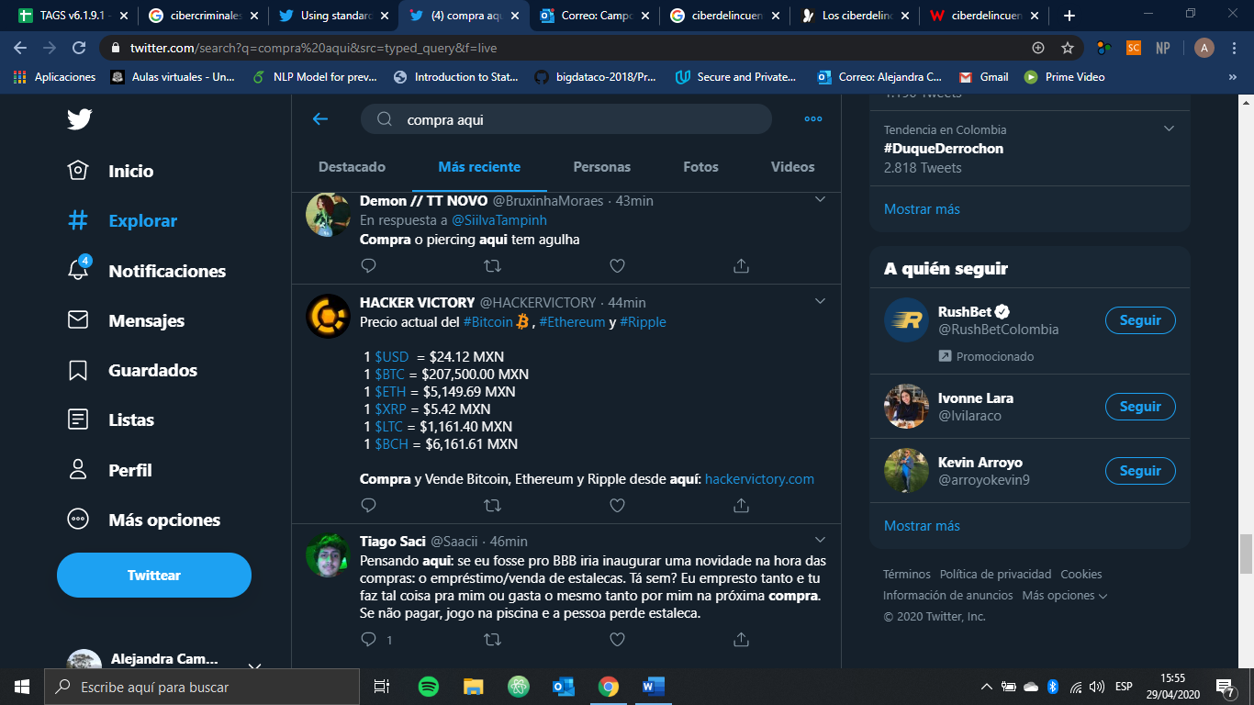

(donation OR promotion OR download) AND (#COVID__19 OR coronavirus OR covid OR covid19)

